BRO. SIGA SOCIAL SERVICE GUILD (BSSSG)
No.29/16L, Kamaraj Avenue, 1st Pallam Street, Vyasarpadi, Chennai -600 039.

32rd Annual Report of BSSSG for the period 2019-2020 presented to the General Body, in its annual meeting held in the office

It is with immense satisfaction, pride and pleasure that I stand here to present this annual report. It is because, though all over existing project were closed due to circumstantial compulsions, we did not perish, but survived and resurrected with more vigour, starting more projects. It may be due to the device awarded, for all the good that we have done to the poor inhabitants of Vyasarpadi slums. It is reason for all of us to rejoice. As you are aware, so long we were working in two Districts. From last year onwards we have taken up Madurai District also, which fact gave us the status of a State level NGO. So I have divided the Report into three sections – Chennai Projects, Kanchipuram Projects and Madurai projects, I have summand up what have done and what we have achieved during the period.
- ECCD Centres Chennai Project
A year back, we started an ECCD programme in Gandhi Nagar Colony at Adyar region. It was not our choice. The HCL Foundation, after conducting a study of Chennai slums, and opted for the area. HCL wanted us to extend our work to this area and we did. Probably the HCL thought, it is worse than Vyasarpadi slum. After entering it, we find that it is as bad on worse than Vyasarpadi slums. Four centres function here. Each centre has 25kids. Each centre has a trained teachers and an Ahya. A professional social worker Coordinate the work. An accounts manager maintained the accounts. HCL provides the support. At present the centres function as a mixture of different Teaching – Learning models. A team of experts in this line from Delhi gave an orientation to the Teachers and continues to do it. From our side, we provided inputs through the teachers, who were trained in the Multiple Intelligence theory of Gardiner followed in the Mathagondapalli Model School at Hozur. But the new Education Policy brings all Pre Schools under the Government Department and has prepared a syllabus to be followed. So very soon, our centres also well have to fall in line with it.
So for activities during the year in Chennai ECCD
S.No | Date | Programmes | No. of Programmes | No. of beneficiaries
1 | 02.04.2019 | World Autism Day | 1 | 15
2 | 27.04.2019  18.07.2019  24.08.2019  27.02.2020 | Medical camp | 4 | 188
3 | 27.04.2019 | Uniform distribution to the children | 1 | 100
4 | 03.05.2019 to 6.05.2019  23.11.2019 | Capacity building and incremental training to staff | 4 | 27
5 | 05.05.2019 | World Environmental day | 1 | 52
6 | 22.05.2019 | Exposure trip for children | 1 | 100
7 | 06.05.2019 | Parents and Stakeholder Meeting | 4 | 175
8 | 06.07.2019 | Children mela | 1 | 150
9 | 11.08.2019 | Celebration of HCL Day |  | 500
10 | 14.08.2019 | Independence day | 1 | 152
11 | 16.10.2019 | Toilet opening ceremony | 1 | 300
12 | 14.11.2019 | Children’s day | 1 | 100

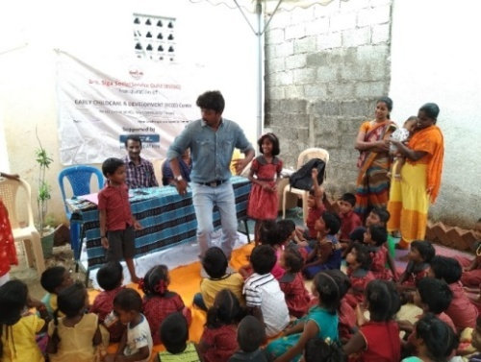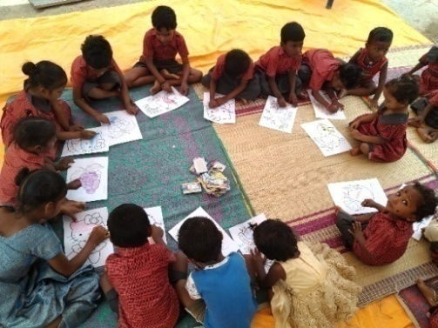
Celebration of Children’ Mela in Chennai Gandhi Nagar ECCD

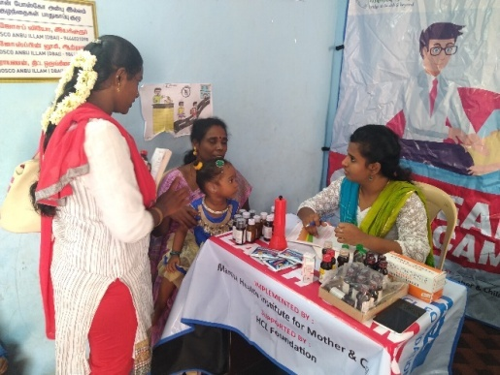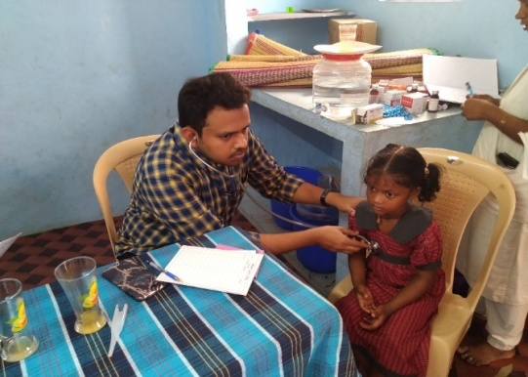
Medical Check up for children Doctors from PHC and Mamta Organisation
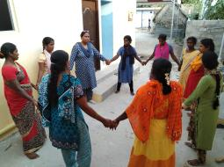
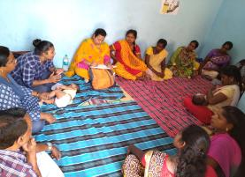

Capacity building Incremental training to ECCD staff and Community women

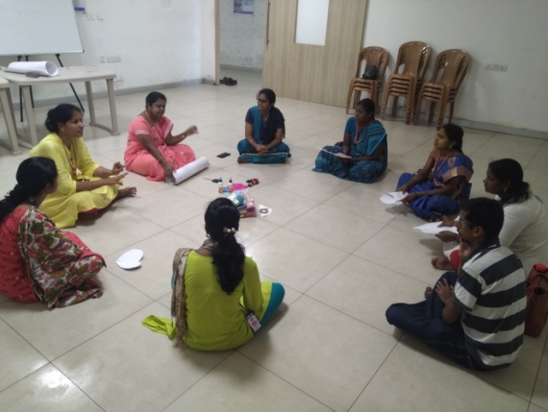
Training Given by Mobile creches from New Delhi
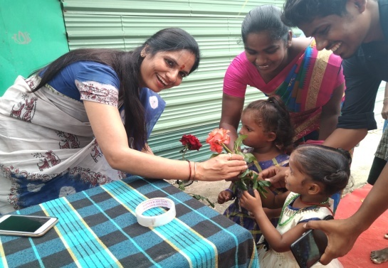
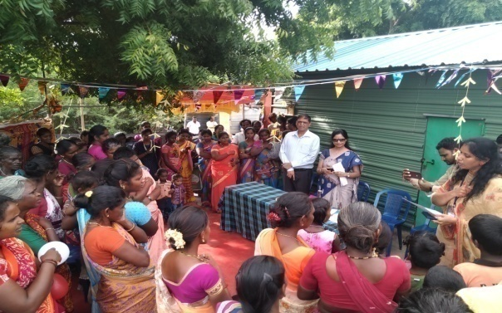

T

Mrs. Nidhi Pundhir Director HCL Foundation visited and donated plantation to Parents

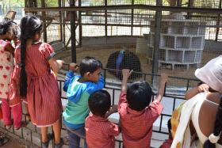
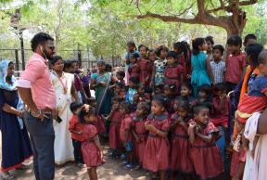

On 22nd May 2019, BSSSG arranged the Exposure Trip for Chennai ECCD Children to National park, Guindy. Mr. Marshal has facilitated the trip as guest of honor. Here Children were exposed to many new things like peacock, snake, Monkey, Fishes, turtles, crocodile etc.
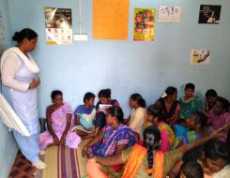
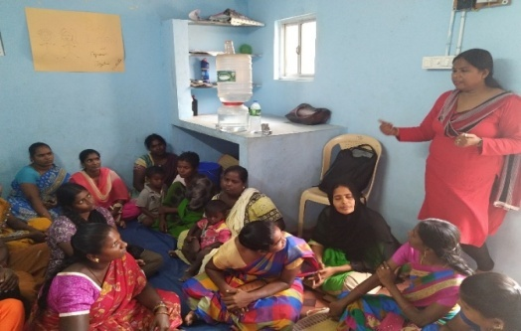
Parents meeting conducted by Trainers from Mobile Creche

Now I take up Madurai ECCD Programme
2. Early Child Care Development
It is after noting over long experience in running Pre Schools at different locations, particularly in slums, that HCL asked us to take up Madurai Slums. Madurai slums are no better rather worse. In some area there is no Electricity or water facility. The women inhabitants are mostly domestic aids. Five ECCD centres function. They are in the same model as Chennai Centers. The Teachers are trained ones. The same type of orientation was given like that was given to the Teachers of Chennai Unit by a team expert from Mobile Creche Delhi. The Coordinator who is station in Chennai makes periodic visits, guides and oversees the Madurai Centers also. I too do Inspection visit. HCL volunteers also involve, in activities such as Medical Check up, exposure visits. The local community consider this as a boon, because there is not facility nearly to provide care and protection to the kids, while the mothers are away for work.
So far activities Completed in Madurai ECCD
S.No | Date | Programmes | No. of Programmes | No. of beneficiaries
1 | 17.05.2019 to 20.05.2019 | Capacity building Incremental training to staff | 2 | 32
2 | 20.05.2019  13.12.2019 | Parents and stakeholders meeting | 4 | 299
3 | 12.05.2019  18.08.2019 | Medical checkup for children | 2 | 132
 | 02.08.2019 | HCL Sports Day | 1 | 140
4 | 15.08.2019 | Independence Day | 1 | 125 children
5 | 05.09.2019 | Celebration of Teachers day | 1 | 15
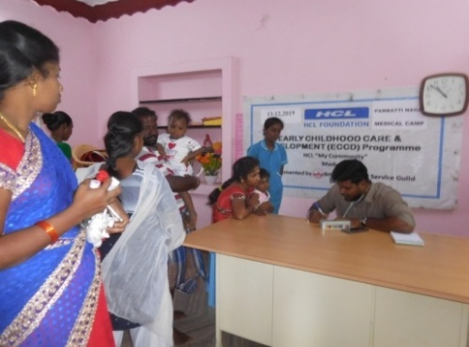
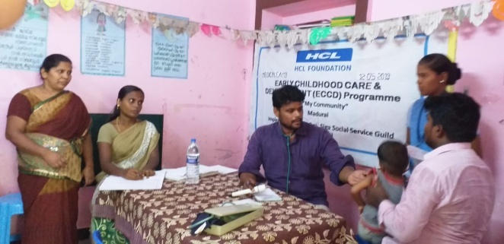

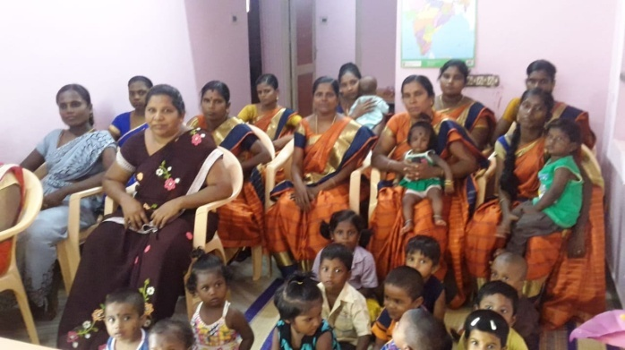
Medical Check up for ECCD Children Doctors from SUHAM Trust
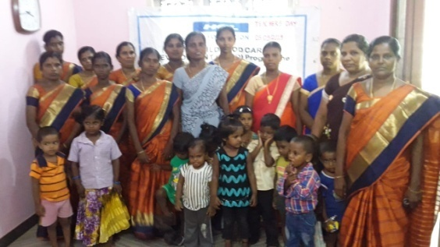
Celebration of Teachers Day in Our ECCD Centre

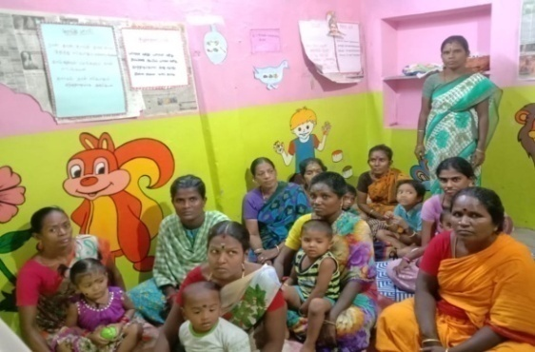

Parents and Stakeholders meeting Conducted by M. Sundaramoorthy Director BSSSG
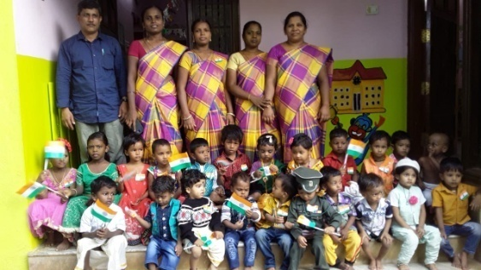

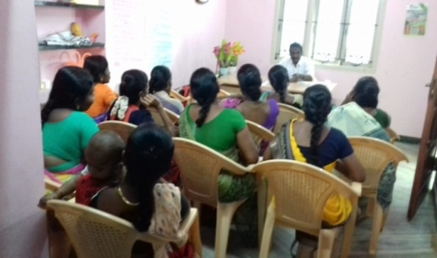
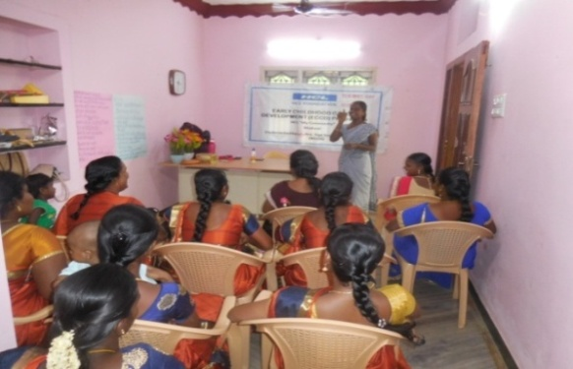
Children Participated an Independence Day

Staff Review Meeting
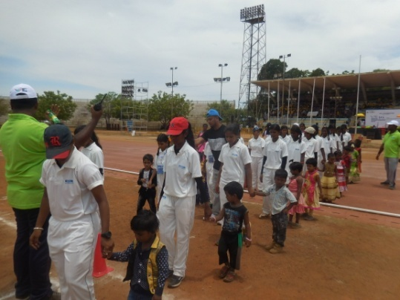
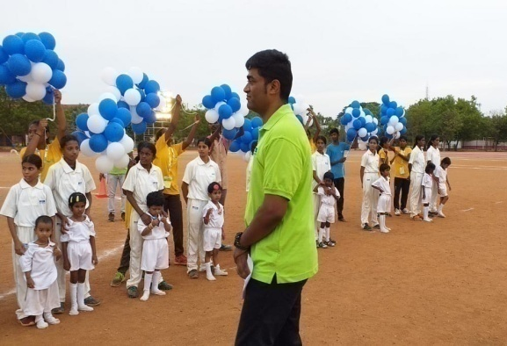

HCL Day Celebration in Madurai Mr. Samuel Ebenezer from
HCL Foundation Lead the Programme

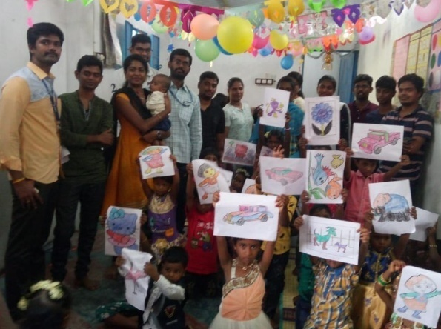
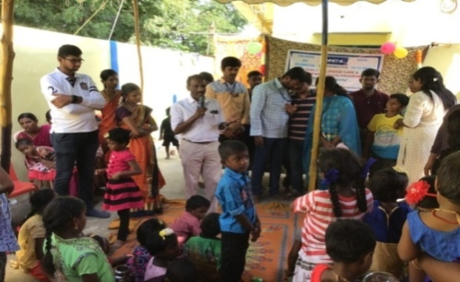

Children enjoyed the Children Mela Programme

3. Child Protection
This project runs in three streams and guided by the Nodal agency, Child Line India Foundation
- Railway CHILDLINE
Child Help Line Desk is operated at MGR Chennai Central Railway Station. The funds are provided by the Government of India. A team of 14 staff manages it. It did a splendid work during the reporting period. The documented report gives the figures shown below:

Total No. Of Children rescued – 1079
Total No. of Children hand over to CWC -947
Total No. Of children restored with parents-832
No. of awareness programme Conducted -16
No. of participants -254

Activities
On 25th May 2019, we are Celebrating International CHILD HELPLINE Day at Chennai Central Railway Premises. The dignitaries of Inspector GRP and Bomb Squad Officials were presented, there are 300 general public witnessed the programme
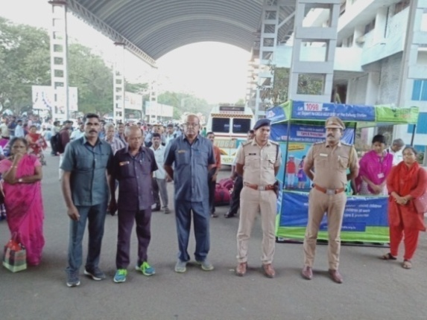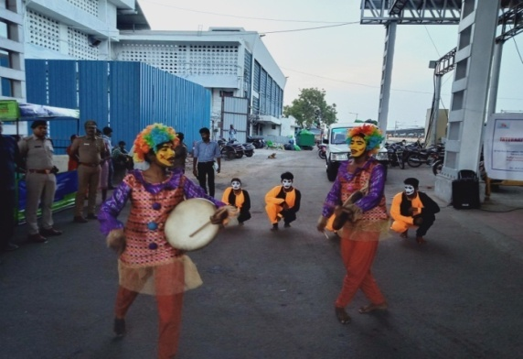
Dignitaries participated in the programme -College students performing the street play
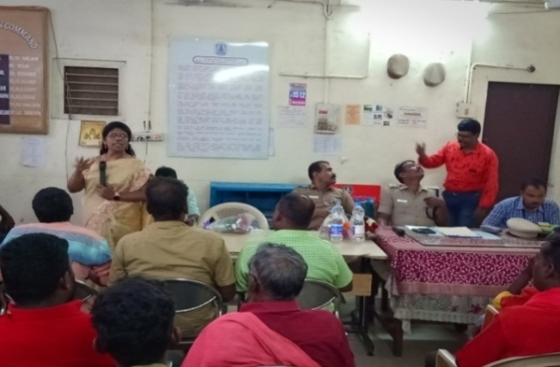
On 26th June 2019, we were organised campaign for Internal day against drug abuse and illicit trafficking
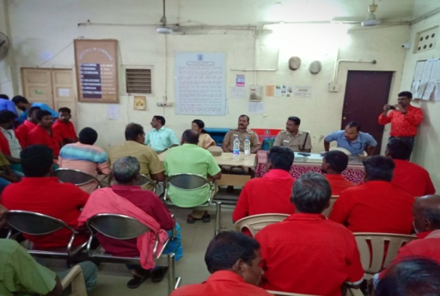
DSP of GRP addressed the Udhayam Volunteers including Resource person Mrs. Rajeswari of TTK hosp the hawkers, porters, vendors, coolies, cleaning staff. Hospital She has explained the topic

Capacity building Training for the team
Date | Topic | Resource person
26.07.2019-27.07.2019 | Refresher Training to the staff regarding: Overview of PCCRS - 1. Indentify About rescued child is addicted to substance abuse?  - Child Labour Amendment act Child Labour (Prohibition and Regulation) Amendment Act, 2016.  - Trafficking IPC sections 370 vs Child Labour Amendment Act.  - POCSO Act.  - Documentation and Case classification  - Intervention protocol  - Ensure child in safety net  - Refresh on Job Description  - Refresh on CHILDLINE Child Protection Policy | Counsellor, TTK - Labour Dept,Govt. of Tamil Nadu -IJM

Special events organised
S.No | Date | Programme | Target group | Content | Event | No of Participants
1 | 12.06.2019 | Anti child labour day | Public – Railway Officials | Child Trafficking | Street Theatre | 70
2 | 30.07.2019 | World Day Against Trafficking | Public – Railway Officials | Child Trafficking | Street Theatre | 80

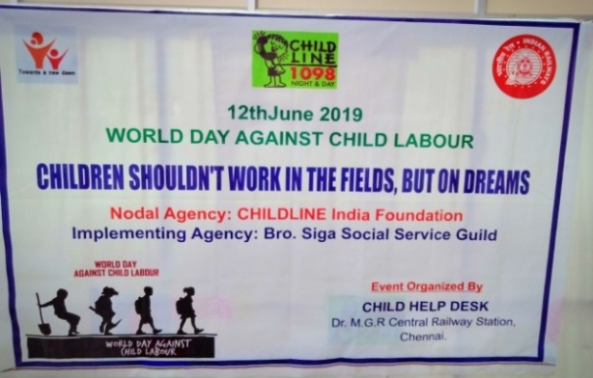
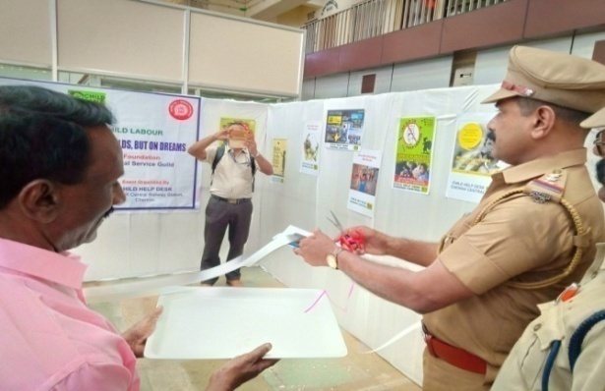
Visible of the Banner Inspector GRP see cutting the ribbon and inaugurating
The program along with
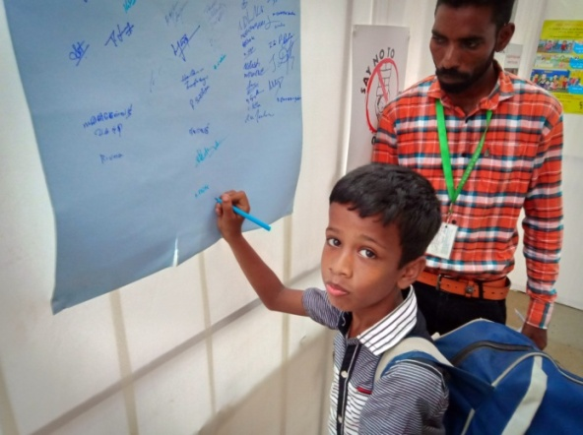
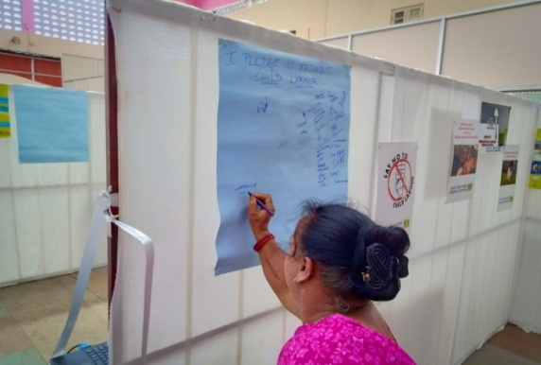
Mr. Sundaramoorthy Founder of BSSSG participating in the signature campaign.
People took pledge to abolish child labour by A child seen signing in the signature campaign
Participating in the signature campaign.
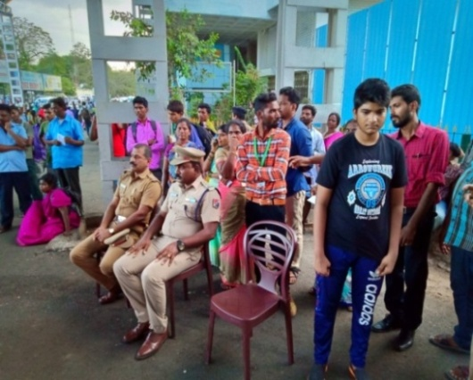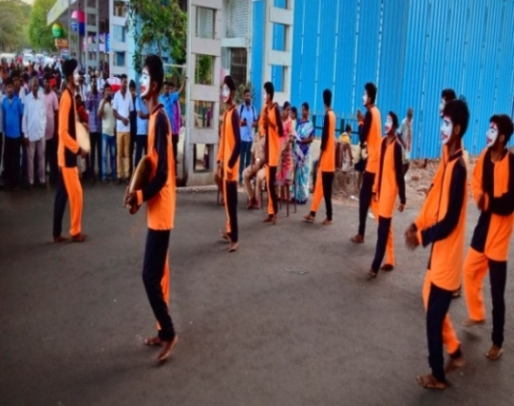
The GRP & RPF Chief Guest of the Programme College Students Performing Street Play

- Satellite Unit
This programme is to hook the smart children, who alight before the terminus to avoid falling in the net of child protection workers. It functions at Perambur Railway Station. During the period end report 58 children were rescued.
- Open Shelter for boys
This unit is for accommodating temporarily the rescued children. Our centre admits boys only. During the period under report 63 passed through its 7 staff manage the centre. Azim Premji Philanthropic Initiative provides the grant.
This is the summery side of the project. It does not mean that everything is rosy in this programme. There were instances of children escaping from the custody of care givers. It happened in Central station desk. It happened in Open Shelter. Such instances cast a black mark on the implementing agency. Hence, memos and termination order had to be given to the staff. It is a risky work and we take extreme caution.
4. Children Club Meeting
On 8th June 2019, the children club meeting at Malligaipoo colony slum was conducted. There are two clubs in the area, the two clubs members participated in the meeting. Mrs. Theresa field worker facilitated the meeting. The children discussed about progress of result, dropout and problems of school fees etc.

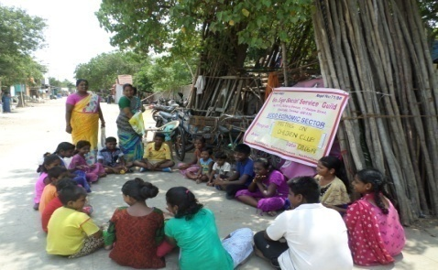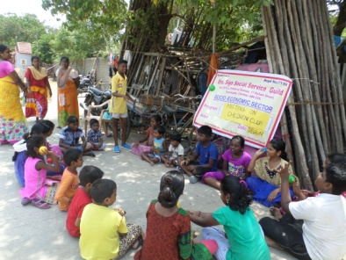
Children Club members participated in the Meeting

5. Community Health
This is the programme which everyone in the area is aware of because the community health workers visit every house. Health Education, complete immunization, pre and post natal care and AIDS Prevention are the main approaches. A variety of related activities were conducted as given here:

Awareness on ANC & PNC care
On 4th May 2019, Mrs. Saraswathi field worker conducted a meeting on ANC & PNC care at B-Kalyanapuram slum. Trained volunteer Mrs. Jayanthi from Jeyam SHG has explained about Pre & Postnatal care of periodical medical checkup, nutritious food, immunization in time, exercise, She also explained the ‘dos ‘and ‘don’ts during pregnancy and after delivery.

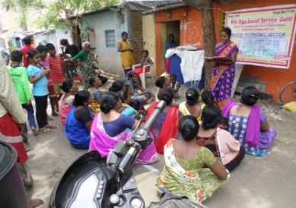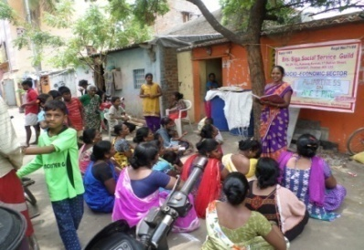
Mrs. Jayanthi from SHG taking class on ANC & PNC care

Awareness on Child Immunization Meeting
The immunisation regimen for different ailments at different age is a matter which causes confusion, even for educated mothers. For illiterate mothers in slums clarification and explanations are needed, including an immunisation for mothers. Hence a group meeting was arranged on 6th November 2019 at Nehru Nagar. Women participated in the meeting
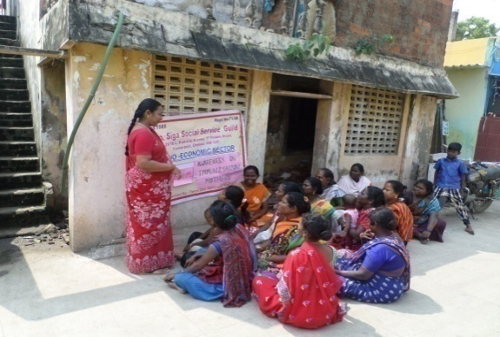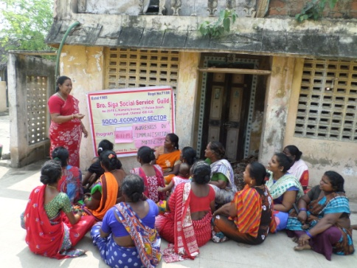
Community development worker Mrs. Theresa conducted the meeting.
Awareness on Cancer
On 9th November 2019, we have conducted awareness on breast cancer and distribution of go green cloth bags programme with the support of Madras Esplanade round table 30 and Madras ladies circle 100. The class conducted by Cancer Institute from Adayar. 51 women benefitted for the programme and learned about symptoms, prevention breast cancer, diet, medical care treatment

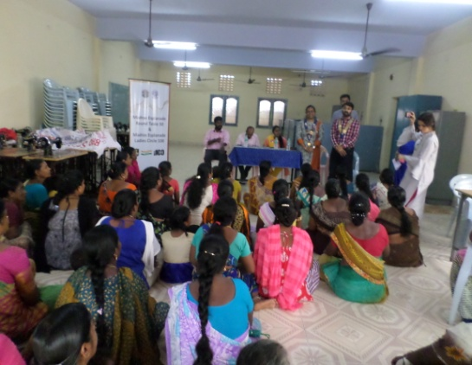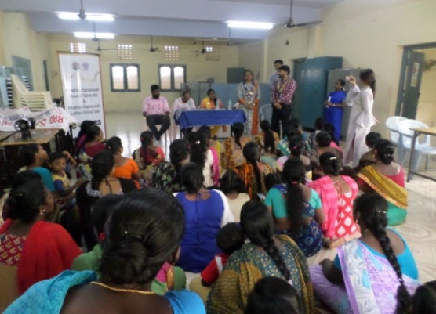
The Madras Esplanade round table and Madras ladies circle Chairman inaugurated the programme

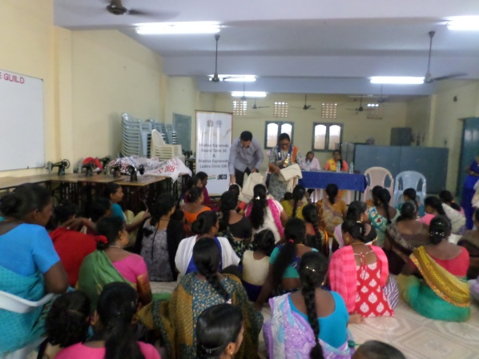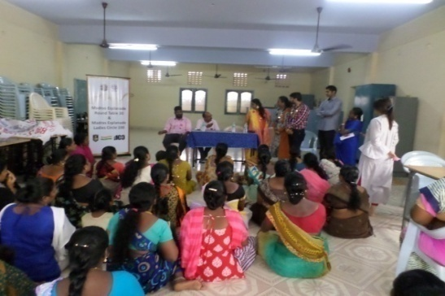

Distributing Go green cloth bags to SHG women

Environmental on Sanitation
On 7th June 2019, Mrs. Saraswathi, field worker organized a meeting on Environment and sanitation at C-Kalyanapuram slum. She has explained about the Health and environmental protection, advised mothers and the public were held to create awareness and educate the community on the infectious diseases and their prevention and protection, usage of safe boiled water etc. These meetings have helped reduce the occurrence of infectious diseases among the slum people.

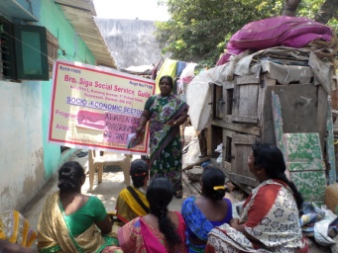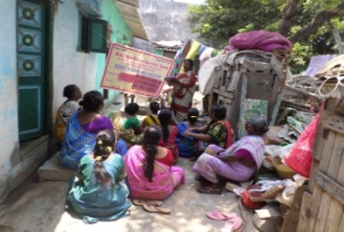
Meeting with Children at slum level

6. Intervention with Female Sex Workers
Members may remember that this Project has been going on the last few years. It continued during the reporting period also. The outputs were good and the impact was substantiated.
I am giving here figures from the documented reports
No. of Sex Workers covered – 1958
No. of Peer Educators trained-25
No. of Counselling sessions help –1013
No. of Women referred for testing –2389
No. of women tested HIV positive – 2
No. of HRG person changed behavioural-78
No. of Community Events organised -2
No. of Persons benefitted - 600
There was a change in the staff during the period. The Project Manager who was working so long resigned. So a new Project Manager was appointed
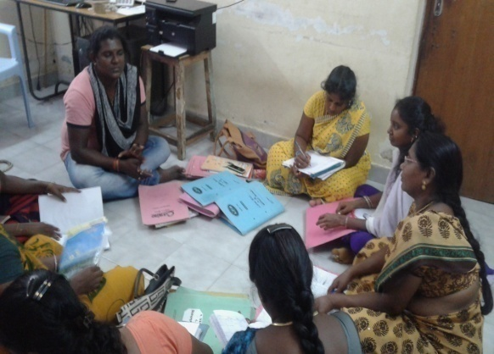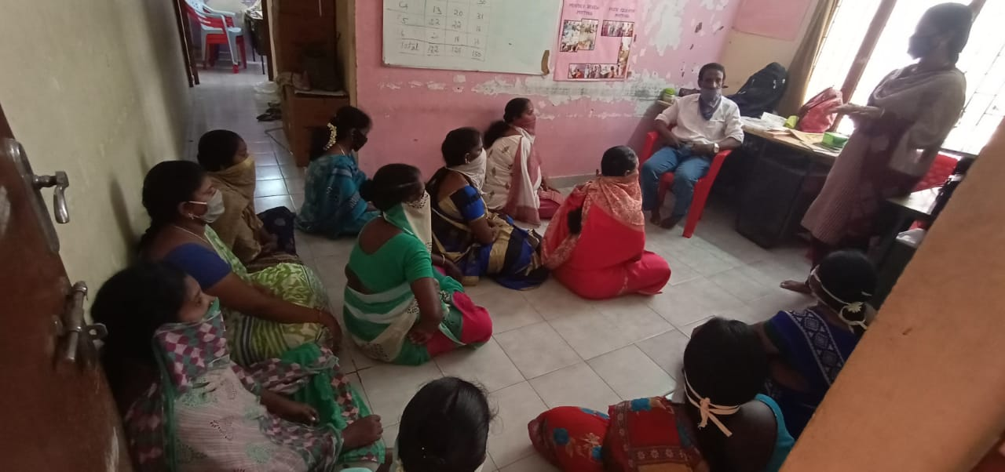
Staff Review Meeting conducted by Mr. Sundaramoorthy Project Director and Project Manager
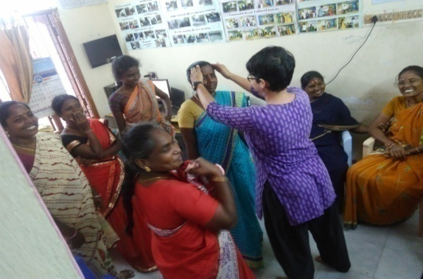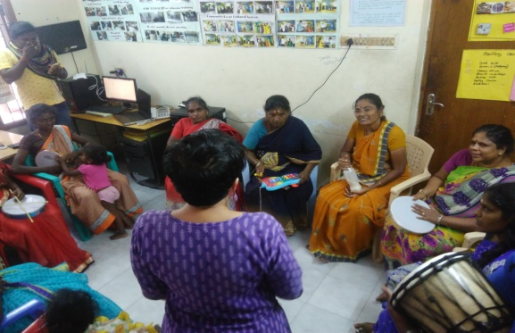
Orientation training to Peer Educators training given by TANSACS

On 12th December 2019 Community Based Screening training was Conducted by Mrs. JAYANTHI MARY (TANSACS-TSU LS /BTS ) in SAIDAPET DIC. In this training Mr.DHANAPAUL (PROGRAMME OFFICER ) ,SWAM, TAA and BROSIGA TI Staffs participated in this training .
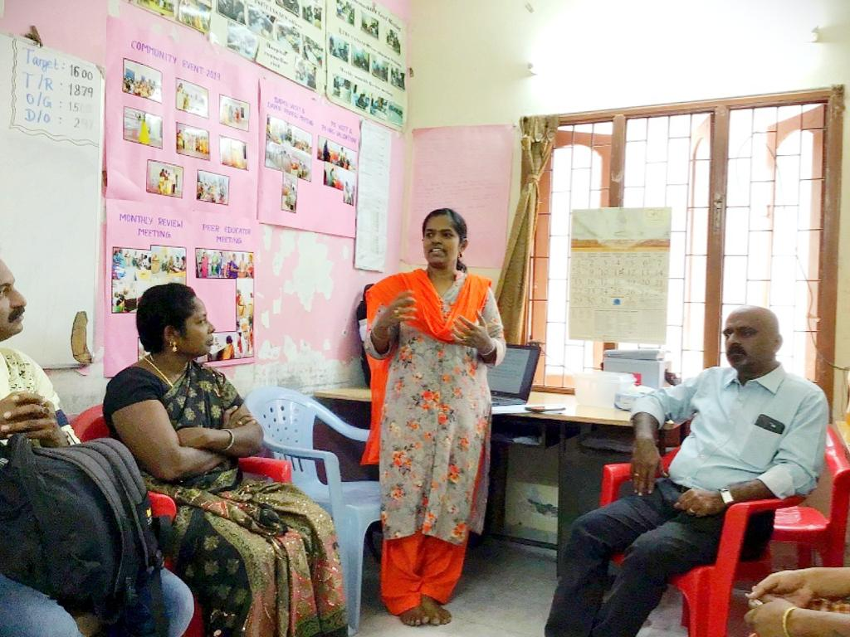
Community Based Screening Training conducted by Mrs. Jayanthi Mary from TANSACS-TSULS/BTS in Saidapet
On 5th March 2020, Evaluation was done by Mr. Rajendran team leader, Mr.Jayapaul Co-evaluator and Mr. Selvam District Programme Manager from TANSAC evaluating the all programme wise activities, result, impact and interaction with the Peer Educators.
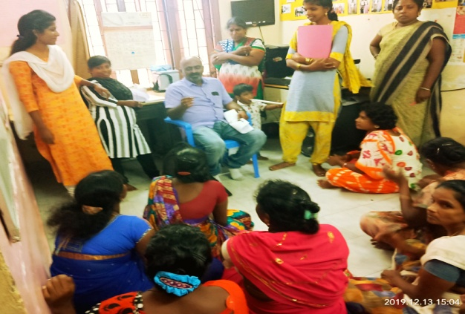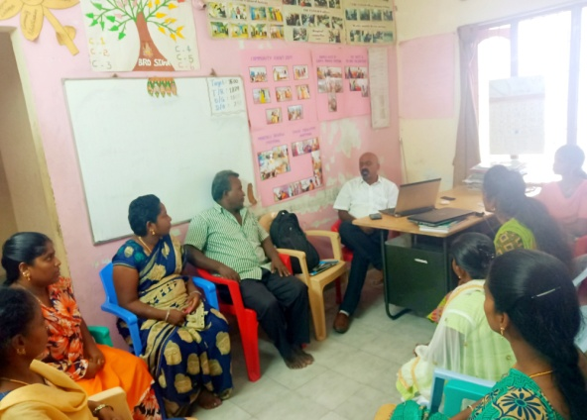
TANSAC Project Officers Evaluated the Programme and Interaction with
staff and Peer Educator

On 27th October2019, Community Event was organised at Samiarthottam community hall Saidapet. In this event Mrs. BHARANI, District Supervisor, Mr.M.SUNDARAMMORRTHY ,Project Director BSSSG ,Mr. Sekar Project Director SWAM , SWAM Organisation Staff and all BSSSG staff participated in the event and cultural programmes were performed. Totally 200 HRGs are participated in this event.

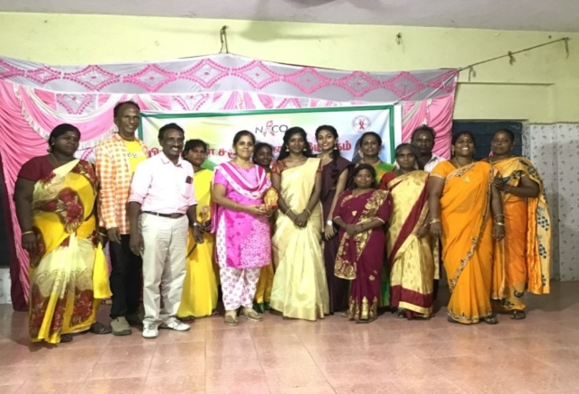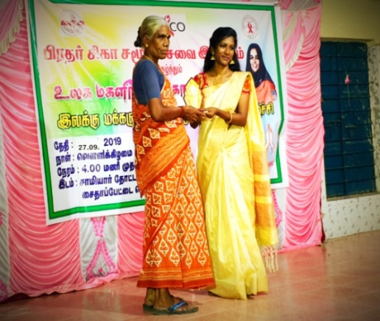
Organised Community Event

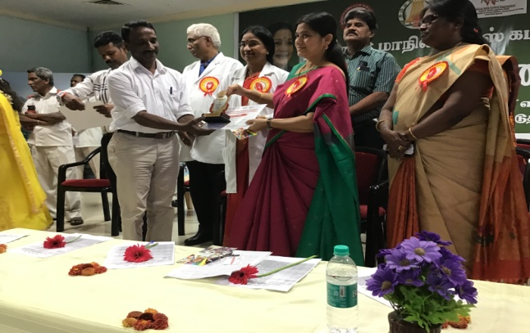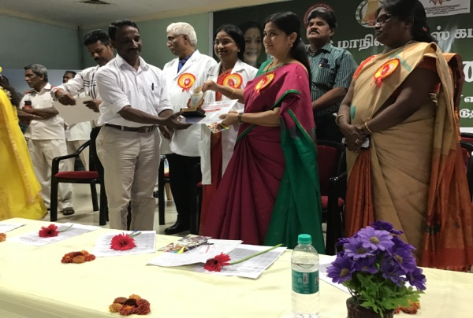
Mr.Sundaramoorthy, Project Director BSSSG got Communities Makes the Different Awards from Mrs. SEETHA LASKSHMI (Chennai District Collector) WORLD AIDS DAY PROGRAMME conducted BY TANSACS in TARGETED INTERVENTION LEVEL at RAJIVGANDHI HOSPITAL.

7. Relief of Poor Revolving Fund
As you are aware, this is one of our oldest of projects. It was initiated by Terre des Hommes Netherlands, for the benefit of the poor women in Vyasarpadi slums and it still continues. I am giving here an overall picture of the project.
- Total amount in circulated Rs.167295631/-
- No. of SHGs formed for it 22
- No. of training conducted -12
- No. of members trained -294
- Amount given as Micro Finance during the period Rs.16260000/-
- Amount of recovery during the period –Rs.17913447/-
- Increased income and assets to 194 families
- No.of Vulnerable Children Participated in Awareness Programme -800
- No. of Boys and Girls received education services – 70
- No.of Community members with children vulnerable to exploitation participated in awareness raising activities - 310
I have given a summary of all projects in Chennai. Now I pass on to Kanchipuram District
I am not as thrilled as a while before, when presenting the Chennai region report; because the Uthiramerur report has become a bit dim, since it took a dip in the activities. But the impact of previous activities is visible 126 houses built for the Irula tribal with aid from Habitat for Humanity India Trust and 15 houses constructed for Narikuravas community and the water sanitation facility offered to the local Girls school, also by Habitat for Humanity are standing movements of our concern for the tribal communities. The slowdown of activities in Uthiramerur during the period is due a slight sreeft in our approach. From our experience in the last few years, in this block we learned a lesson. The area has a sizable chunk of population of Irulas and Narikuravas. Their prime need is not Education or Health, but substance. First they have to be face from hunger. There has to be money for survival and livelihood to sustain. So, for survival, we started a new approach. That is Micro finance. The previous Revolving Fund was expanded.
No. of families received Micro finance: 324
No. of families increased income and assets: 176
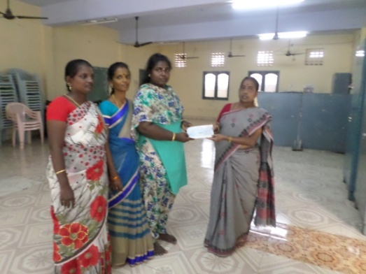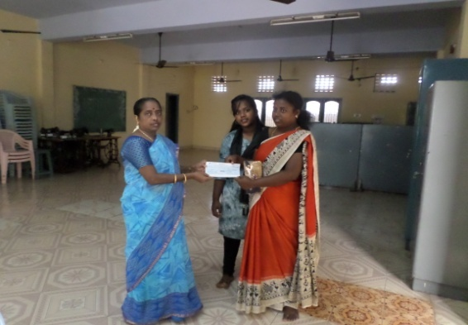
Revolving Fund Relief of Poor Loan Cheque issued to Chennai SHGs
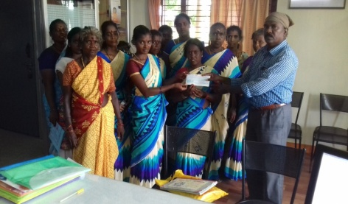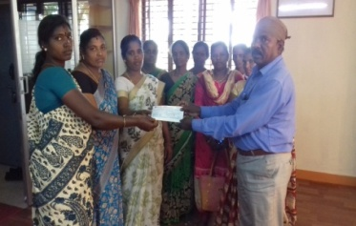
Revolving Fund Relief of Poor Loan Cheque issued to Uthiramerur
Village SHGs
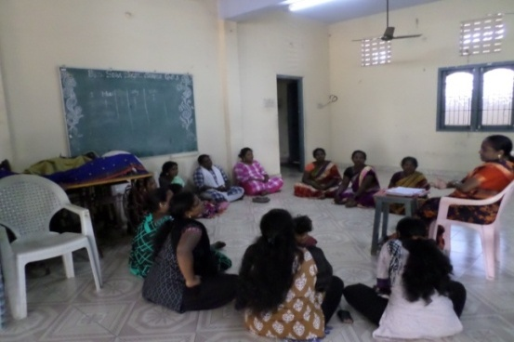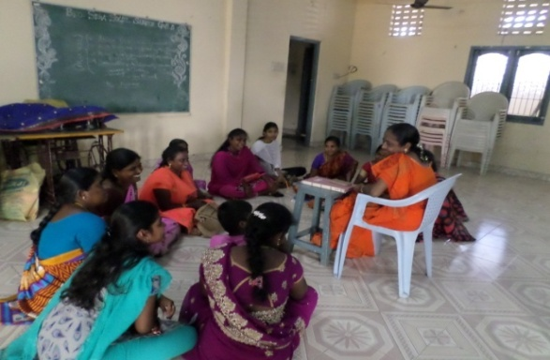
Meeting with Chennai SHG Members at BSSSG Training hall
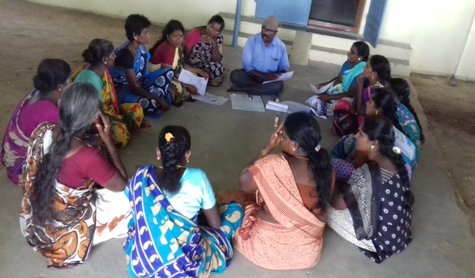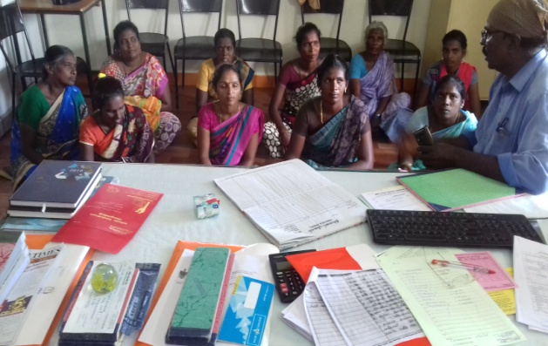
Meeting with SHG members in Uthiramerur block Kanchipuram District

Case Study: 1

Name : A. Gayathri
Name of SHG : Nithiyamalli Magalir SHG
Place : Sathiya Moorthy Nagar
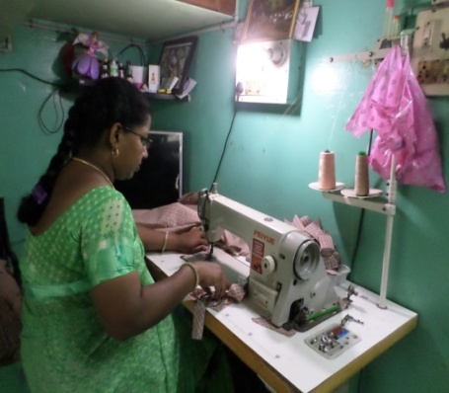

I am a resident of S.M.Nagar. My family consists of husband, daughter in 6th standard and two year old son. My husband is an Auto rickshaw driver on salary. With his earning, I was running the family on a tight budget. When the expenses exceeded, I used to take loan on high interest. In this condition, I had only one thought: “I must improve”.
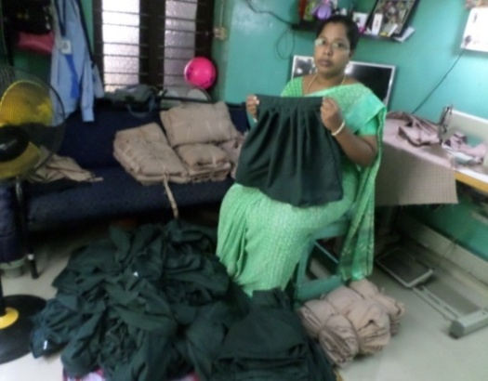
It was at this time, that BSSSG worker were forming SHGs in the area. I was also made a member. With difficulty I saved money. When the amount became sufficient, I took a loan of Rs. 10000/-. I had great ambitions. BSSSG referred to SMART Industrial Training Centre of the Government and I joined tailoring training and completed. I had no idea, how to start Tailoring business.

So, as a Stop-Gap, I started vegetable sales. Took another loan and stabilized the business. Then I slowly began Tailoring. A third loan was availed and an Auto rickshaw was bought on Installment. Contract for stitching school uniform was also taken. These were wise investments. Income from three sources, pour in from Auto rickshaw, vegetable sales and tailoring. I have no debts now. I have realized my ambition.

Case Study -2
Mrs. Manjula w/o Haribalan
Kunnavakkam village
Thendral Magalir SHG
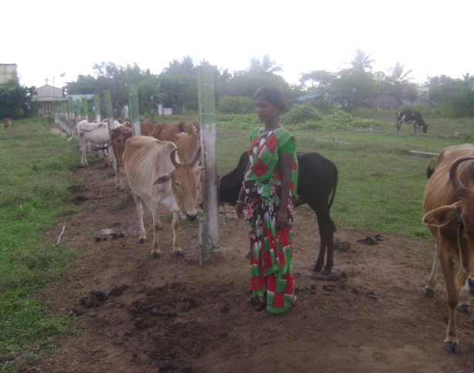
A family of four members, own house, husband is illness, having one son and one daughter, daily wage earner. The husband wife had to work. If they do not go for work, there will be no food at homes. Due to this condition, the sons dropped out from school.
Then came the turning point.

They were sensitized on the benefits of joining SHG. Manjula decide to join Thendral Magalir SHG. She saved money. She took a first loan. Dairy is the best income generating mechanism in this part. They earned sufficiently in the first year. Then she got three loans. A dairy with 13 cows and doubled the income. Apart from the asset, then whole imaged changed and became what thing are now.

- Additional support for women empowerment
- During the reporting period 18 women were trained for tailoring course and given certificate to 18 women. They have applied tailoring machine in Government of Social Welfare board.
- MCLC 73 and Ladies Circle India donated 5nos Sewing machine to our target women and Transgender community of Vyasarpadi slums in Chennai. On recommendation of Praise Foundation
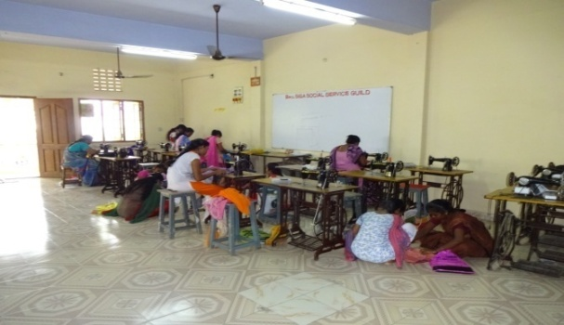
BRO.SIGA TAILORING UNIT
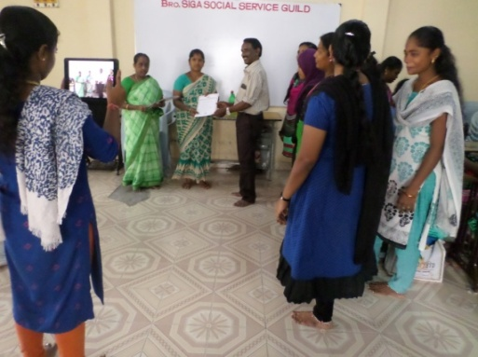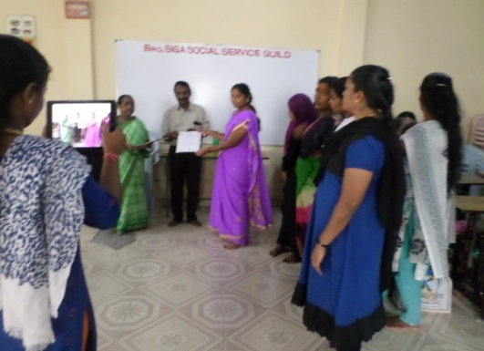
BSSSG Founder Secretary Mr. Sundaramoorthy Issued tailoring course certificate to trained women

- Antenna Trust
Another our Crore rupees from Antenna Trust was put as core fund starting dairy, since it was found to be a thriving investment.
During the reporting period 24 SHGs with 250 members got Antenna loan an amount of Rs. 12500000/- invested the money for milch animals through this they are selling milk and earning income.
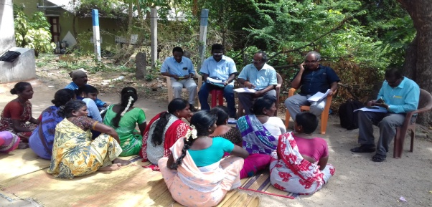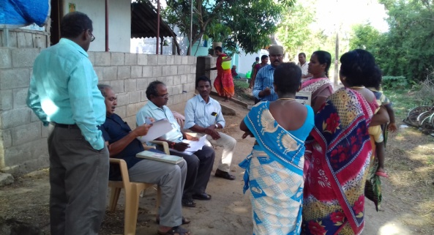
Antenna Trust Managing Trustee Mr. Manoharan and team directly field visit interacted with the SHG members and verified the loan formalities at Muthalamman SHG and Velathamman SHG in Uthiramerur villages of Vyalore and Thirupulivanam
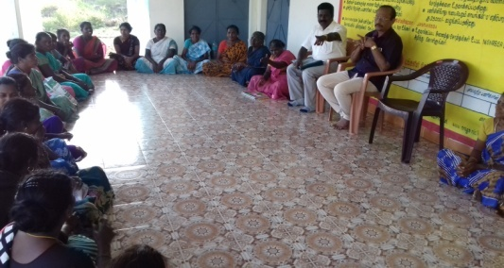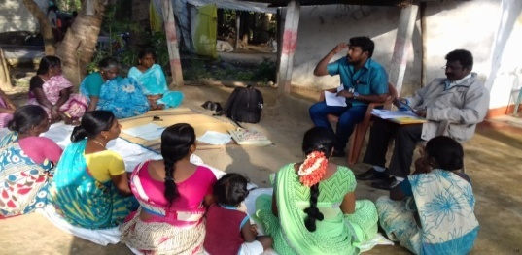
Mr. Sundaramoorthy BSSSG Director and Mr.Manoharan Antenna Trust Managing Trustee visited and meeting with SHG loan Beneficiaries
This programme continues, successfully.
- Associated Programmes
When I say that we have expanded our work expanding services and extending area, it does not mean, we have ignored Vyasarpadi slum. We shall never do it because it is our Mother slum on which we shed our tears, several, blood and energy. We continued it, during the reporting period also.
- Praise Foundation
It is not a funding agency. It is a body set up by the Corporate in Chennai. Its function is to screen NGOs, scan their worthy proposals and link NGOs to the Corporate. During the reporting period Praise Foundation supported programmes were given below:
Educational support for children of SHG women
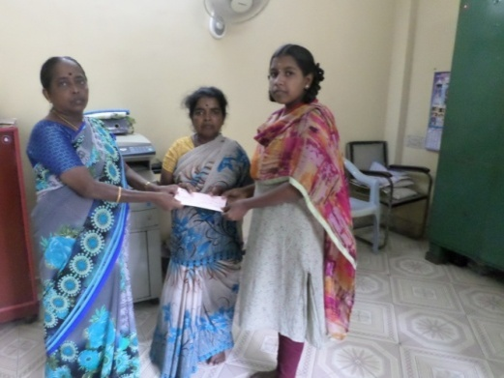
- Temenos India Private Limited, through Praise Foundation has paid fees an amount of Rs.22000/- for three School students, who are children of SHG women.
Pavithra -14yrs old, studying 10th standard, Donbosco Hr.Sec.School, Vyasarpadi
It is a family of three members. Father, mother and younger brother. Father does odd work in houses and makes Rs.100/- a day. This happened because he started changing the gender. Mother takes food from Amma Canteen.
Helplessness – There is no money to pay fees. So she cannot attend classes. Some relatives helped to buy Uniform and school bag. Unable to attend school, she was terribly dejected. A donor came forward to pay her school fees recommended by Praise Foundation.
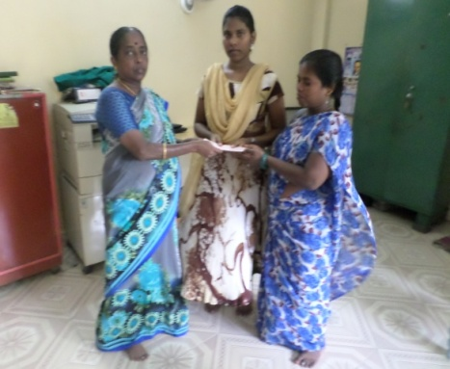
K. Kaviya aged 16, Studying +1, Don Bosco Hr. Sec. School, Vyasarpadi
Family composition
Father, mother, younger brother
Family Situation
Father is working in a plastic pipe company, mother domestic aid and also selling sarees, brother studying in 10th standard. Rented house.
Father is alcoholic. So the family is in utter poverty. So money is borrowed from money lenders. Praise Foundation helped to pay the fees of this girl through a donor

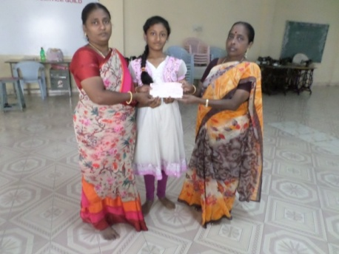
R. Jeevitha 15 yrs old, studying 8th standard in St. Ann’s Mat. Hr. Sec. School, Madhavaram
Problem
Semi orphan. Father died two months back. He was a cooli. Grant parents live with them. They meet the food expenses.

After the death of father, the mother started selling water can supply and idly. But with that income the school fees cannot be paid. There is no other source of help. A donor paid the fees on the recommendation of Praise Foundation

I have come to the end of the report. Before closing it I would like to record here, our gratitude to all over well wishers and funding agencies.
- Terre des Hommes, Netherlands
- Tamil Nadu State AIDS Control Society
- Child Line India Foundation – Ministry of Women and Child Development
- Azim Premji Philanthropic Initiative
- HCL Foundation
- Praise Foundation
M. Sundaramoorthy
Founder Secretary
Bro.Siga Social Service Guild

